**LAB # 01**

**Task 1: Implement the network on packet tracer. and** **Ping,**

**(i) PC0 from PC5,**

**(ii) PC6 from PC2,**

**(iii) PC3 from PC1,**

**Also, display the results in the simulation mode of packet tracer. Attach snapshots of the pinging results and the network created.**

**Solution :**

|  |  |
| --- | --- |
| End Device | IP Used |
| PC0 | 172.16.1.1 |
| PC1 | 172.16.1.2 |
| PC2 | 172.16.1.3 |
| PC3 | 172.16.1.4 |
| PC4 | 172.16.1.5 |
| PC5 | 172.16.1.6 |
| PC6 | 172.16.1.7 |

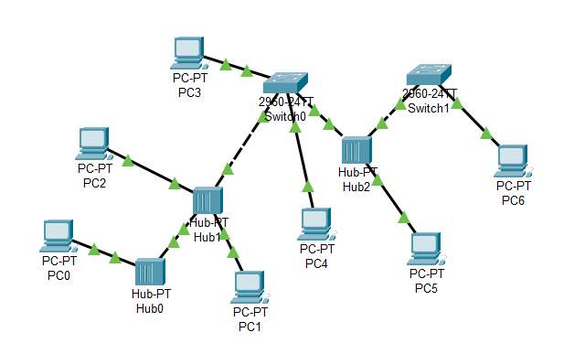

**OUTPUT :**

1. A picture containing calendar

   Description automatically generated**ping PC0 –> PC5**

1. **ping PC6 –> PC2**

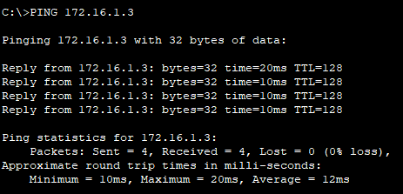

1. Table

   Description automatically generated**ping PC3 –> PC1**Calendar

   Description automatically generated